CCH Simulator Guide

**Port-in – Perform Accept for NPR**

1. After port-in submission from MCP, NCCF or DBreeze, query from the PPA GUI port-in status monitoring page. The status displayed for Port-in Status is ‘NPR Submitted, pending NPR Accept/Reject’.

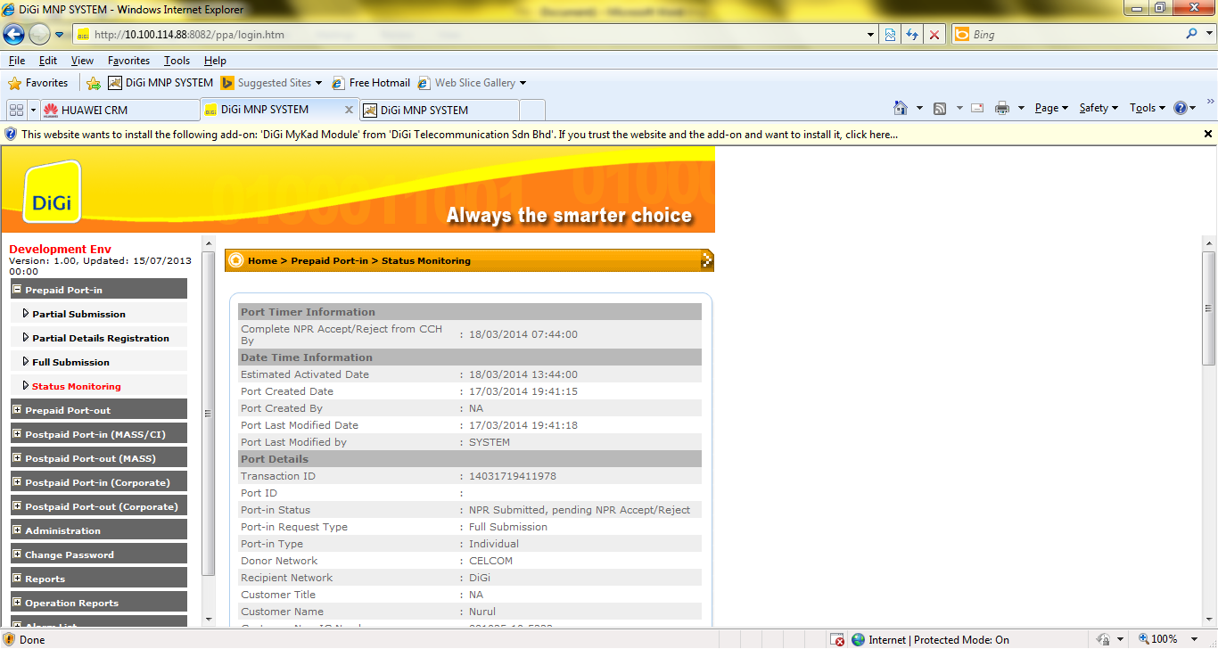

1. Log-in to PPA Tools – CCH Simulator.
2. Fill in :
   1. Port ID – format should be PYYYYMMDDHHMISSXXXX
   2. Message code – select ‘NPR Ack’
   3. Service Type – select MOBILE INDIV for Mass, MOBILE CORP for Corporate
   4. Message ID – copy the Transaction ID from Status Monitoring
   5. Porting Request Form ID - copy the Transaction ID from Status Monitoring
   6. Other mandatory fields, fill up accordingly.
3. Click Submit.
4. Check status from PPA GUI port-in status monitoring. The Port ID is updated for the transaction.
5. Using PPA Tools - CCH Simulator
6. Fill in :
   1. Port ID – format should be PYYYYMMDDHHMISSXXXX
   2. Message code – select ‘NPR Accept’
   3. Service Type – select MOBILE INDIV for Mass, MOBILE CORP for Corporate
   4. Message ID – copy the Transaction ID from Status Monitoring
   5. Response Due Date – fill in due date as current date/time. IMPORTANT to fill in as current date, otherwise due date based on MNP timer will be defaulted
   6. Porting Request Form ID - copy the Transaction ID from Status Monitoring
   7. Other mandatory fields, fill up accordingly.
7. Click Submit.
8. Check status from PPA GUI port-in status monitoring. The Port-in status will update to ‘NPR Accepted, activation in progress’
9. If all completed at CSG and CRM, the port-in status will be updated to ‘NP Activated’.

**Port-out – Trigger Port-out initiation**

1. Log-in to PPA Tools – CCH Simulator.
2. Fill in :
   1. Port ID – format should be PYYYYMMDDHHMISSXXXX
   2. Message code – select ‘NPR’
   3. Service Type – select MOBILE INDIV for Mass, MOBILE CORP for Corporate
   4. Message ID – fill in any ID (eg YYYYXXXX)
   5. Response Due Date – fill in due date as current date/time. IMPORTANT to fill in as current date, otherwise due date based on MNP timer will be defaulted *set the response due date with buffer around 10-15 minutes (or 1 hour).
   6. Porting Request Form ID - fill in any ID (eg YYYYXXXX)
   7. Customer New IC Number/Old IC/Passport/Armed Force ID – fill in the correct customer ID that is registered in CRM or Prepaid IN
   8. Other mandatory fields, fill up accordingly
3. Click Submit
4. Check status from PPA GUI port-out status monitoring. The Port-in status displayed will be
   1. NPR Accepted, NPR Accept Sent (If port-out evaluation passed all validations)
   2. NPR Rejected, NPR Reject Sent (If port-out evaluation failed. Reject code(s) will be displayed)
   3. NPR Accepted, Pending SMS Validation Accept/Reject. Click bypass SMS verification, status changed to ‘Pending NPR Accept Send’. Wait until NPR Accept Sent before trigger confirmation.

**Port-out – Trigger Port-out confirmation**

1. Using CCH simulator, continue from the submission for Port-out initiation.
   1. Port ID – should be using the previous Port ID from the Port-out inititation
   2. Message code – select ‘NP RFS Broadcast’
   3. Service Type – select MOBILE INDIV for Mass, MOBILE CORP for Corporate
   4. Message ID – copy the Transaction ID from Status Monitoring
   5. Porting Request Form ID - copy the Transaction ID from Status Monitoring
   6. Response Due Date – fill in due date as current date/time. IMPORTANT to fill in as current date, otherwise due date based on MNP timer will be defaulted
   7. Other mandatory fields, fill up accordingly

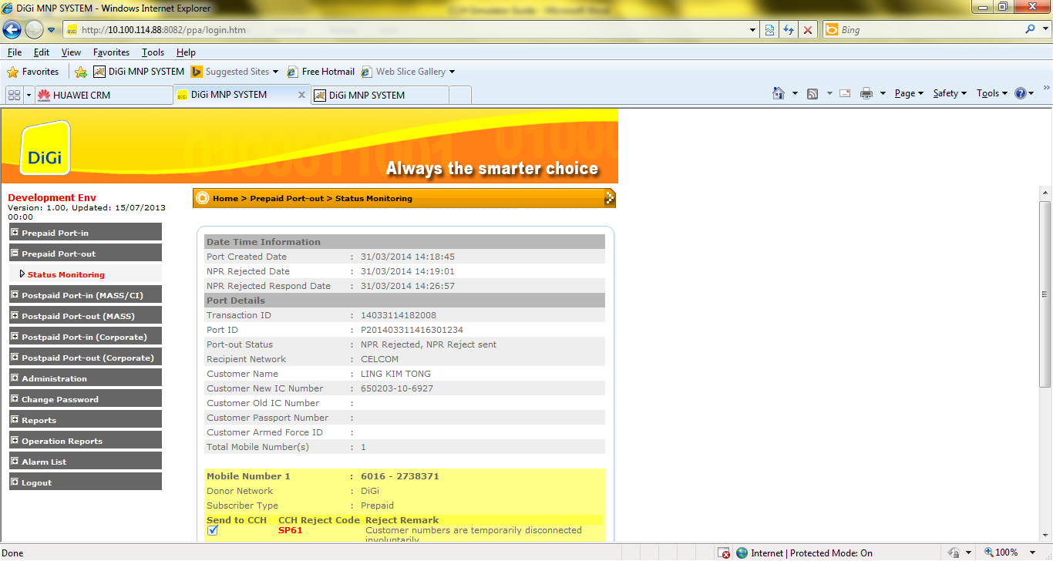

1. Click Submit
2. Check status from PPA GUI port-out status monitoring. The Port-in status displayed will be ‘Port Deactivated, NP Activated Sent’ if port-out is completed without issues.

**Port-out – Trigger Port-out cancellation**

1. Using CCH simulator, continue from the submission for Port-out initiation.
   1. Port ID – should be using the previous Port ID from the Port-out inititation
   2. Message code – select ‘NP Cancel’
   3. Service Type – select MOBILE INDIV for Mass, MOBILE CORP for Corporate
   4. Message ID – copy the Transaction ID from Status Monitoring
   5. Porting Request Form ID - copy the Transaction ID from Status Monitoring
   6. Other mandatory fields, fill up accordingly
2. Click Submit
3. Check status from PPA GUI port-out status monitoring. The Port-in status displayed will be ‘NP cancelled’.

http://10.89.10.51:8082/ppa/login.htm

http://10.89.10.51:8083/ppatool/login.htm